

Project #3 Bluetooth LED

Takatsu Naoaki 015746144

CECS 447 Fall 2018

Microprocessor + Controllers III

5, November 2018

**Introduction**

In this project, students changed LED colors through the HC-05 Bluetooth module using UART. There are two programs for this project: setup and communication programs. Bluetooth settings will be set by user input. LED will change color by inputting characters in the serial terminal connected by the Bluetooth module.

**Operation:**

Setup:

The setup mode will require baud rate of 38400 baud/s. To enter the setup mode, press and hold the button on the Bluetooth module while powering on the TM4C123G programming board. Upon reset, the user will enter AT commands to the Bluetooth module through UART0 using serial terminals such as Tera Term. Once the settings are done, turn off the board’s power and unplug the EN port from the Bluetooth Module.

<https://youtu.be/mwgpp2c43nw>

Communication:

The communication mode will require baud rate of 57600 baud/s. To enter communication mode, simply power on the board prior to making sure EN port on the Bluetooth module is unconnected. Next, connect a device, such as a smartphone or a laptop, to the Bluetooth module and enter the password you have chosen in the setup mode. Once connected, open a serial terminal application to interface with the Bluetooth module. Press the reset button and type in the desired character to change the LED color on the board.

<https://youtu.be/uCOwDRlAaFg>

**Hardware Design:**

Since UART1 is being used, RX will be PB0 and TX will be PB1. VCC gets 5 volts and the ground is connected to ground. The board’s RX will be connected to the Bluetooth module’s TX and vice versa.

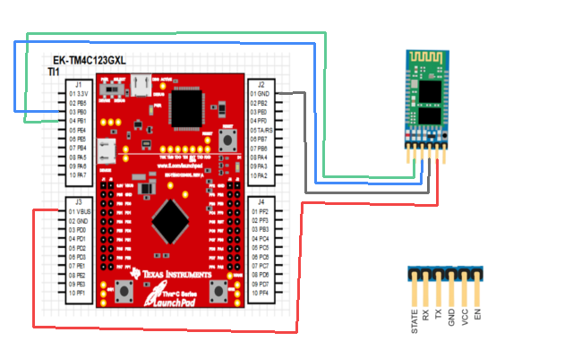

**Software Design**

Port B2 is used for the speaker output while port F4 and F0 are used as push button inputs, switch 1 and switch 2 respectively, to toggle its states. Once the buttons are pressed, a delay function is executed to serve as a debounce. Switch 1 will toggle its state between a 0 and 1, 0 for off and 1 for on. Switch 2 will toggle between 3 states as each state represents the order of the songs. A song switch flag is checked in the play music function in order to change songs at any time.

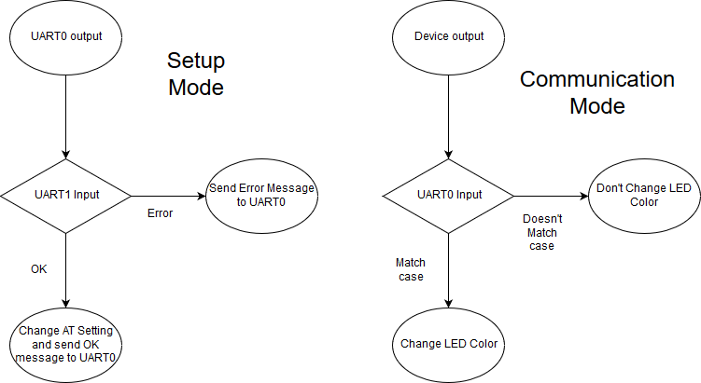

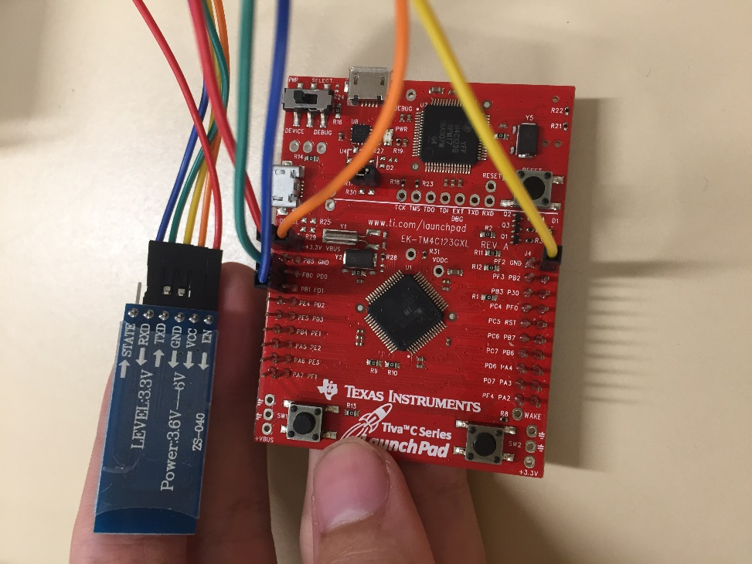

**Conclusion**

In this project, I have faced many hardships. First, the HC-05 Bluetooth module was not compatible with the IOS platform, thus rendering my iPhone useless. So, I have tried using my laptop, but my Bluetooth was undetectable. This was solved by changing the AT+CLASS value to 1. Next, I needed to download a serial interface for the laptop to enable inputs to the Bluetooth. Lastly, I had PortF_init commented which made my LED’s not change colors. Otherwise, the setup mode was done successfully in almost a single try.